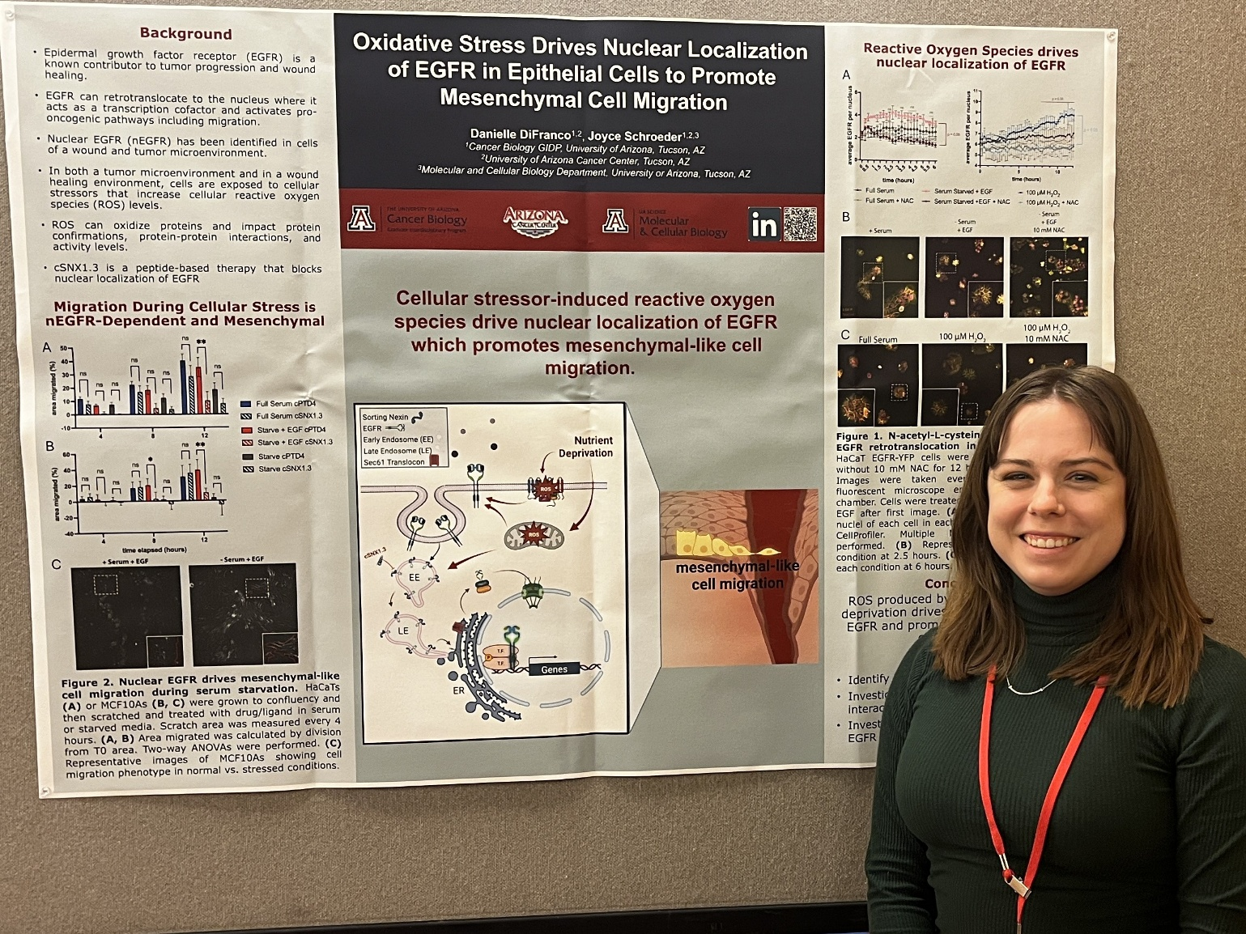

I had an excellent experience attending The Protein Society’s 39th annual symposium from June 25th to June 29th, 2025, in San Francsico. The first evening, there was a networking event that allowed students to meet with each other before the rest of the conference. Through this event I connected with several other graduate students at varying universities, making connections for potential new collaborators or for a future job. Throughout the conference I attended many great talks on advances in methodology and mechanisms of proteins. In particular, I really enjoyed the session on *Proteins Moving, and On the Move Inside the Cell* and the session on *Proteins and Lipids: Fusion, Fission, Budding* as I study the movement of the protein Epidermal Growth Factor Receptor (EGFR) and its interactions with lipid membranes in relation to breast cancer metastasis.

In the *Proteins Moving, and On the Move Inside the Cell* session, Dr. Moriah Beck’s talk introduced me to a newer actin binding protein called Palladin that is upregulated in breast cancer cell line and may contribute to metastasis. This protein may contribute to the mechanisms of metastasis we are studying. I really enjoyed Dr. Bianxiao Cui’s talk during this session on curved adhesions and integrins. She talked about a newer type of cell adhesion called curved adhesion that could play a big role in cancer cell migration along the extracellular matrix and how this may drive metastasis. This curved adhesion is promoted through a specific integrin protein–integrin ß5 which may interact with EGFR and is therefore a mechanism of cell migration I could pursue in my studies of breast cancer metastasis. In the *Proteins and Lipids: Fusion, Fission, Budding* session, both Dr. Lauren Jackson and Dr. Brett Collins spoke on the retromer complex for protein trafficking. This complex is important for the retrograde trafficking of EGFR that I study so both of their talks gave me a deeper insight and the most up-to-date knowledge of the moving parts of this complex. I also really enjoyed Dr. Olivier Julien’s talk on how to detect post-translation modifications by mass spectrometry. I am investigating the oxidation of EGFR, so I am interested in using mass spec as a method to detect these oxidative changes. I look forward to investigating all these topics further and potentially reaching out to these researchers in the process.

The networking lunch that The Protein Society provided was very helpful as I begin to look at the next step in my career. I was able to sit at a table with graduate students and a facilitator–Dr. Emma Carroll to discuss how to obtain a post-doctoral position. Dr. Carroll gave us tips on reaching out to labs for positions, insight into how the interview process can go, and different reasons to pursue a post-doctoral position. This is important information for me to know as I begin approaching the end of my Ph.D. program. I am also interested in pursuing a career related to science policy so Dr. Carroll gave me information on policy internships I can participate in that I was not aware of previously. This event was very beneficial for my career development. I also had the opportunity to meet with a St. Jude post-doctoral recruiter during the conference. Dr. Manali Ghosh told me of the wonderful opportunities St. Jude has to offer post-docs and how the position could further enhance my career development and set me up for my next career step as well.

I had the wonderful opportunity to present a poster on my current research project. As most attendees were dedicated protein scientists, I enjoyed hearing a fresh perspective on my work. The people who visited gave me great suggestions on how to tackle my future directions on the effect of reactive oxygen species on proteins involved in EGFR nuclear localization.

Overall, this conference opened my eyes to new avenues of the proteins involved in metastasis and EGFR localization, introduced me to new methods that I could use in future experiments, and gave me insight into the next steps in my career.